LiPo = Lithium polyester battery

Fully charge ≈ 4.2 V

Fully discharge ≈ 3.0 V

* Quad should stop when the potential difference is about 3,2V (?)

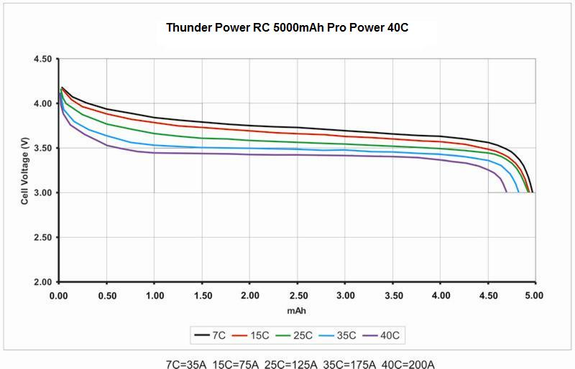

Image: LiPo battery discharge rate.

\*note: the chart is for 5000mAh one, our may be a bit different.

One way to monitor the battery is by using an in-flight balance voltage indicator (Link: <http://hobbyking.com/hobbyking/store/__14627__Hobbyking_2_4s_In_Flight_Balance_Voltage_Indicator.html>).

The battery life is shown by LEDs only. However, we could try to read the signal sending to the LEDs and link it to the Raspberry Pi to monitor the battery.

There is also a way to monitor battery using the raspberry pi itself using analog to digital converter:

Ref: <http://raspi.tv/2013/controlled-shutdown-duration-test-of-pi-model-a-with-2-cell-lipo>

Tutorial for using the ADC to read analog data:

<https://learn.adafruit.com/reading-a-analog-in-and-controlling-audio-volume-with-the-raspberry-pi/overview>

This is for reading audio volume, however, it is possible to read the voltage input.

The ADC for raspberry pi is a 10-bit ADC, which read values from 1 to 1023, approximately up to 3.3v. So we need a voltage divider or potentiometer to reduce the input voltage to about only 3.0v.